**ITECH2003** **Web Design**

**Brief Report**

**Student name:**ZeyuWang

**Student ID:** 3042855

1. **Tested Browsers:**

I thoroughly tested my site on the latest versions of Google Chrome, Microsoft Edge, and Lenovo browsers. On Google Chrome, Edge, Lenovo Browser, all features like flexible layout, CSS elements, and JavaScript work as expected, navigation and all breakpoints are fully compatible, and the website works well. All browsers effectively handle responsive design at break points, ensuring proper layout on desktop, tablet, and mobile views. The progress bar on the skills page that uses JavaScript, the image wheel on the gallery page, the message prompt on the contact page, etc., all work seamlessly in all browsers.

1. **Page layout:**

My website is designed with **Flexible** Layout to ensure that it delivers a consistently good experience across a variety of screen sizes and devices. The minimum width of the website is 7**00px**, due to the different layout of the content of each page, when the browser window width decreases below this, the content will start to look crowded and difficult to read, and will not continue to fit comfortably on the screen. Therefore, the design of the website is optimized for adaptive effects in the screen width range of 1000px to 1700px to ensure smooth browsing across different devices. To enhance the user experience, I have added additional **break points** for several key pages, such as the home page, destination page, and Skills page, which ensure that the page content is properly displayed on different screen sizes. And I set the image to flexible structure, as the screen shrinks, the image will also shrink in equal proportions.

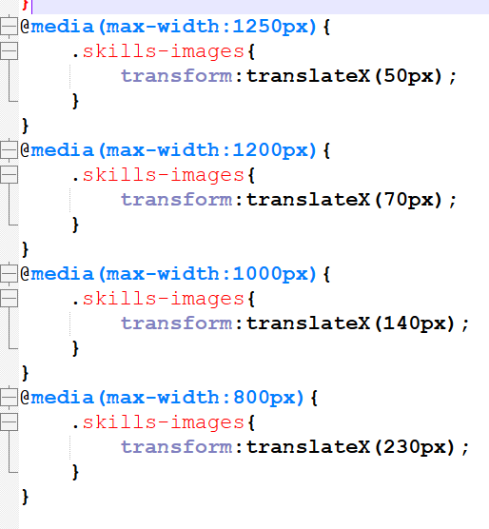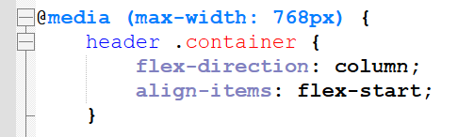

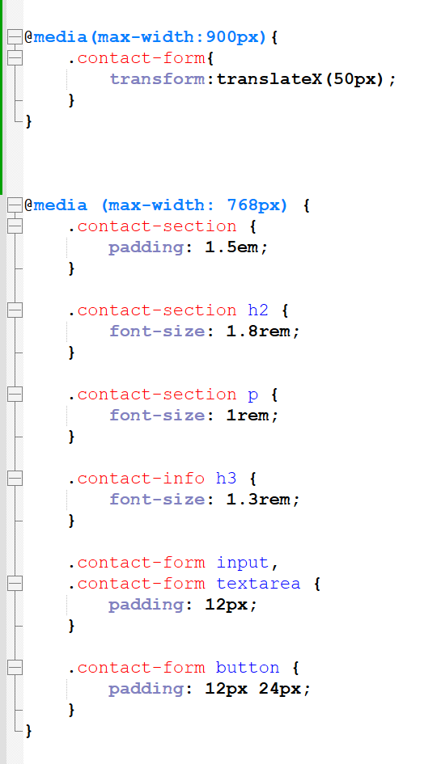

**Best resolution:**

The best resolution of the website is 1920x1080, at this resolution, the page layout is spacious and each element has enough space to display, and the user experience is the most smooth. On higher resolution screens, such as 2560x1440 or 4K screens, the page will automatically scale, ensuring that the page content is presented in the best proportion.

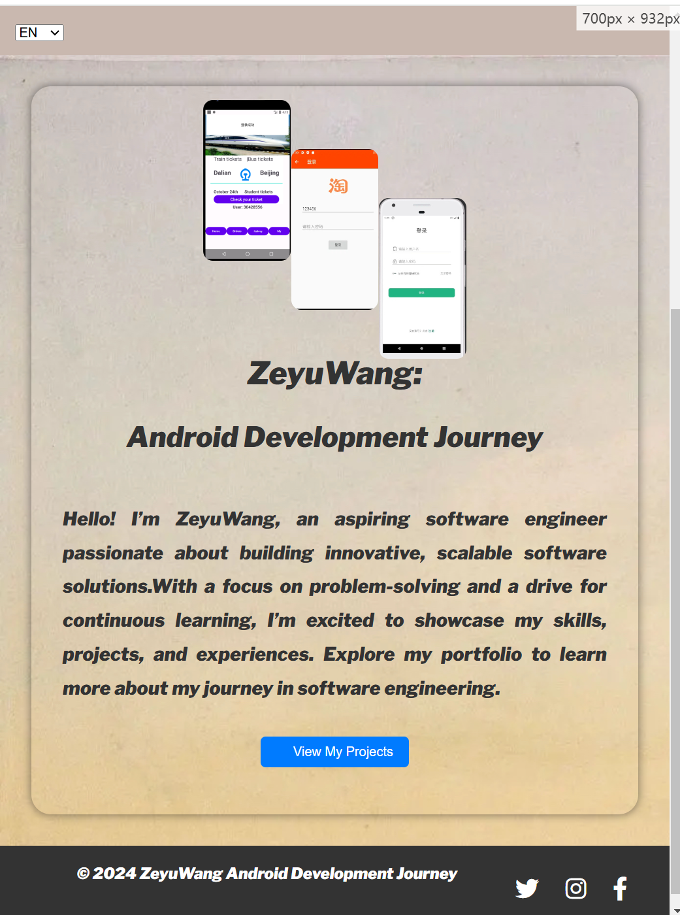

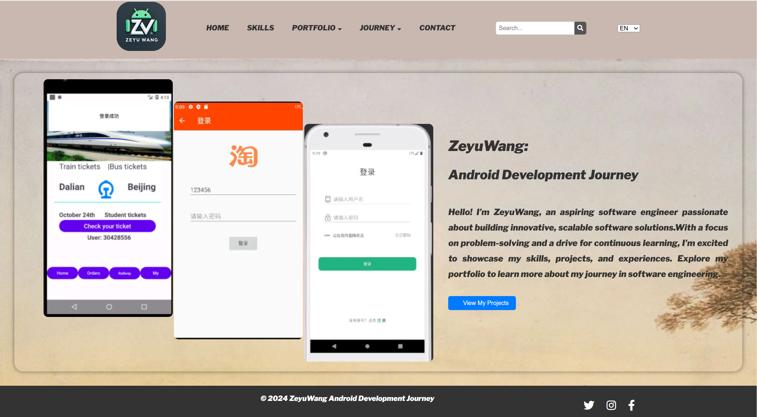

1. **Changes to the design document:**

**Skills page:** To improve readability and user experience, we moved the progress bar and ICONS below the text. This layout is not only more concise, but also improves the screen adaptability of the page, so that it can maintain a good display effect on different devices.

**Gallery page:** In order to provide a better visual experience, the Gallery page has adjusted the slides into two. This change makes it easier for users to navigate through images and optimizes the screen fit of the page, avoiding the limitations of landscape arrangement.

**Internship page:** The placement of the Internship page was further optimized by swapping text and images. This adjustment not only enhances the aesthetics of the page, but also makes the presentation of information more clear and understandable.

**Goals, Contact, and Career pages:** I changed the layout of Goals, Contact, and Career pages from landscape to portrait to improve screen adaptability. Portrait layout makes better use of screen space, making page content clearer and more comfortable to display on a variety of devices.

1. **Highlight:**

**CSS3 Visual Elements:**

1. In order to improve the visual effect of the page, each page has added Outlines, shadows and rounded corners to make the focus of the page more prominent. These designs not only add layers to the page, but also make the page appear more modern and sophisticated.

2. Designed the mouse hover style for the navigation menu, and the menu items will turn white when the mouse hover to enhance the sense of interaction. At the same time, the drop-down menu bar is designed to facilitate users to quickly switch between different pages and improve the ease of use of the website.

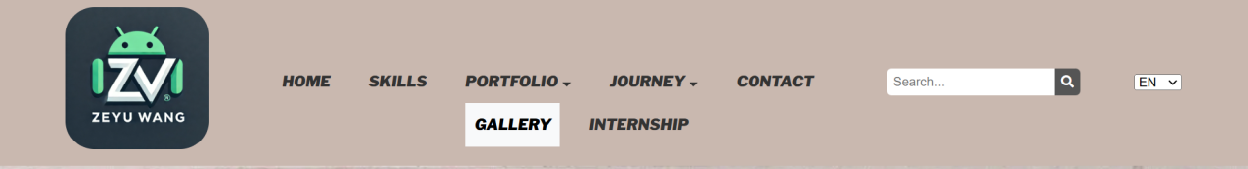

3. For each picture, the effect of magnifying when the mouse is hovering is added, and the rounded corner design is set to provide a better visual effect. This design allows users to get a more vivid image display while browsing, improving the overall user experience.

**JavaScript/jQuery scripting effects.**

1. The skills page introduces a dynamic progress bar, which makes the mastery of each skill more intuitive. Through these dynamic effects, the user is able to clearly understand the proficiency level of each skill and inspire a stronger sense of interaction.

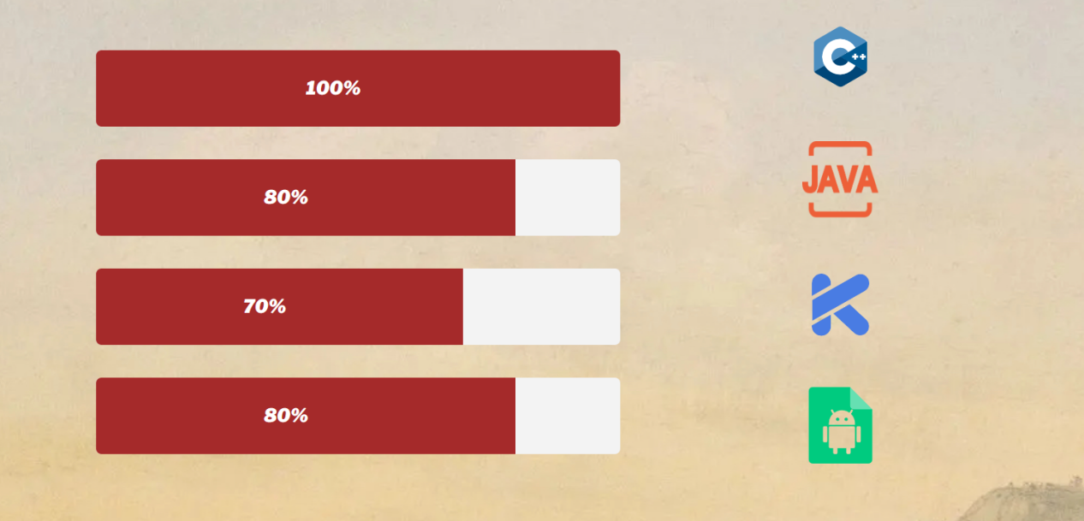

1. On the Gallery page, the first photo of the slide show is fixed and the user can enjoy the details of the fixed image. The left and right buttons can be clicked to switch to the previous or next picture. At the same time, the slideshow is set to auto-play, which automatically switches to the next picture every five seconds. In order to improve the user experience, when the mouse hovers over the picture, the autoplay will be paused, and the user can freely browse each picture.

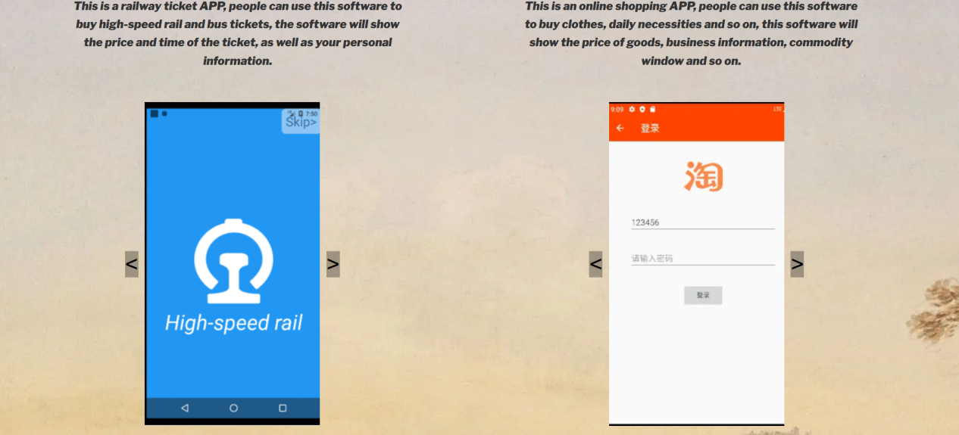

1. The form on the Contact page is strictly verified to ensure that the user must complete everything and comply with the correct format in order to submit. After a successful submission, the user will receive a prompt confirming that the form has been submitted correctly.

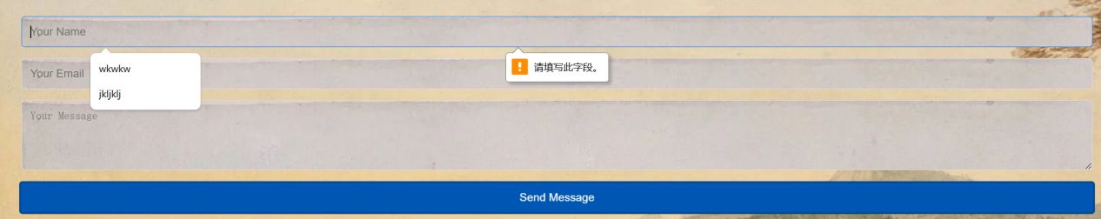

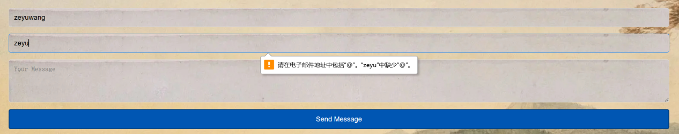

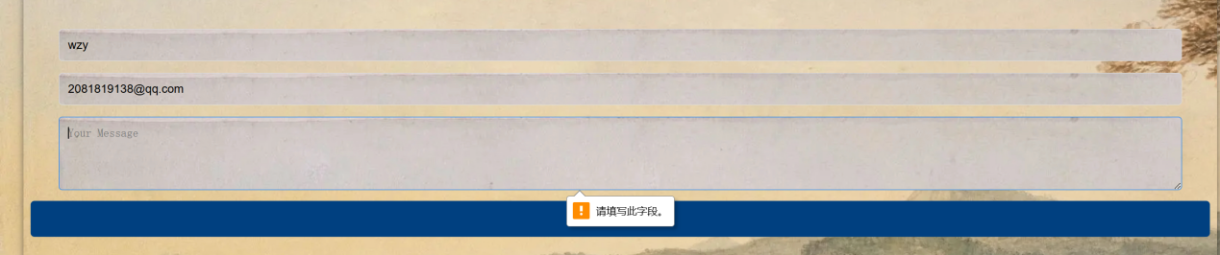

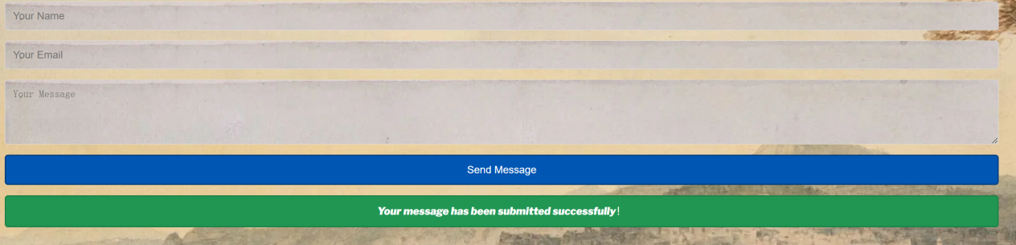

· I integrated social media links in the contact page. Visitors can contact me directly through these links to ensure that communication is smooth. Of course, the social media icon in the lower right corner can also be clicked and redirected to the relevant page to get in touch with me.

· By clicking on the logo in the top left corner of the page, users will be able to quickly return to the home page, improving navigation ease.